|  |  |  |  |  |  |  |  |  |
| --- | --- | --- | --- | --- | --- | --- | --- | --- |
| **Mapbox Studio Components** | | **Zoom Levels** | **Form** | | **Color** | | **Type** | **Texture** |
| **Administrative Boundaries**   * *admin-0-boundary* * *admin-1-boundary* * *admin-0-boundary-disputed* | | Visible at all levels, subnational boundaries only visible when zoom-in. |  | | Admin-0-boundary(country) with disputed lines:    Background:    Admin-1 (state or province):    Background: | |  | Admin-0: dashlines    Admin-1: dashlines |
| **Buildings**  **(including labels)**   * *block-number-label* * *building-number-label* * *building* * *building-extrusion* * *building-underground* | | Only visible after zoom-14 |  | |  | |  |  |
| **Land** & Water   * *land* * *landcover* * *national-parks* * *landuse* | | Visible at all levels |  | | Land:    Land cover:    National-parks: | |  |  |
| Land & **Water**   * *water* (+ shadowing) * *waterway* (+ shadowing) * *land-structure* (structures on the coastlines; lines and polygons) | | Water and waterway are visible at all levels; land-structure only visible after zoom-13 |  | | Water:  Described in texture  Waterway:    Waterway shadow:    Land-structure: | |  | Water: |
| **Natural Features (Labels)**   * *water-point-label* * *water-line-label* * *natural-point-label* * *natural-line-label* * *waterway-label* | | Visible at all levels |  | | Water Label:  Natural Feature Label: | | Quintessential: |  |
| **Place Labels**   * *country-label* * *state-label* * *settlement-major-label* * *settlement-minor-label* * *settlement-subdivision-label* | | Country-label zooms out after 2.5  Continent-label zooms out after 7  State-label 2.1-5.8  Settlement-major 0-12  Settlement-minor only visible after zoom 3.8 |  | | Continent:    State:    Subdivision:    Halo color for all: | | Dancing Script: |  |
| **Points of Interest**   * *poi-label* (text or icon; Maki is used by default) | |  |  | |  | |  |  |
| **Mapbox Studio Components** | **Zoom Levels** | | | **Form** | | **Color** | **Type** | **Texture** |
| **Road Network**  **(including labels)**  Complex hierarchy avail within the following categories:   * *road-labels* * *bridge* * *turning-feature* (e.g., one-way) * *road* * *tunnel* | Smaller roads only visible at higher zoom levels. | | | Different Line width with different road types and line width varies across zoom range. | |  | Dancing Script: |  |
| **Satellite Imagery**   * *satellite* (can fade in a largest zoom level) * *background* |  | | |  | |  |  |  |
| **Terrain**   * *hillshade* * *cliffs* * *contours* |  | | |  | |  |  |  |
| **Transit (including labels)**   * *aerialway* * *bridge-raile-tracks* * *bridge-rail* * *road-rail-tracks* * *road-rail* * *ferry-auto* * *ferry* * *aeroway-line* * *aeroway-polygon* |  | | |  | |  |  |  |
| **Walking, Cycling (including labels)**   * *bridge-pedestrian* (+ many related categories) * *golf-hole-line* * *road-pedestrian* (+ many related categories) * *tunnel-pedestrian* (+ many related categories) |  | | |  | |  |  |  |
| **Custom Datasets**  Depth | Visible at all levels | | |  | |  |  | Brushalike: |
| **Background Layer** | Visible at all levels | | |  | |  |  |  |

Inspiration From Van Gogh:

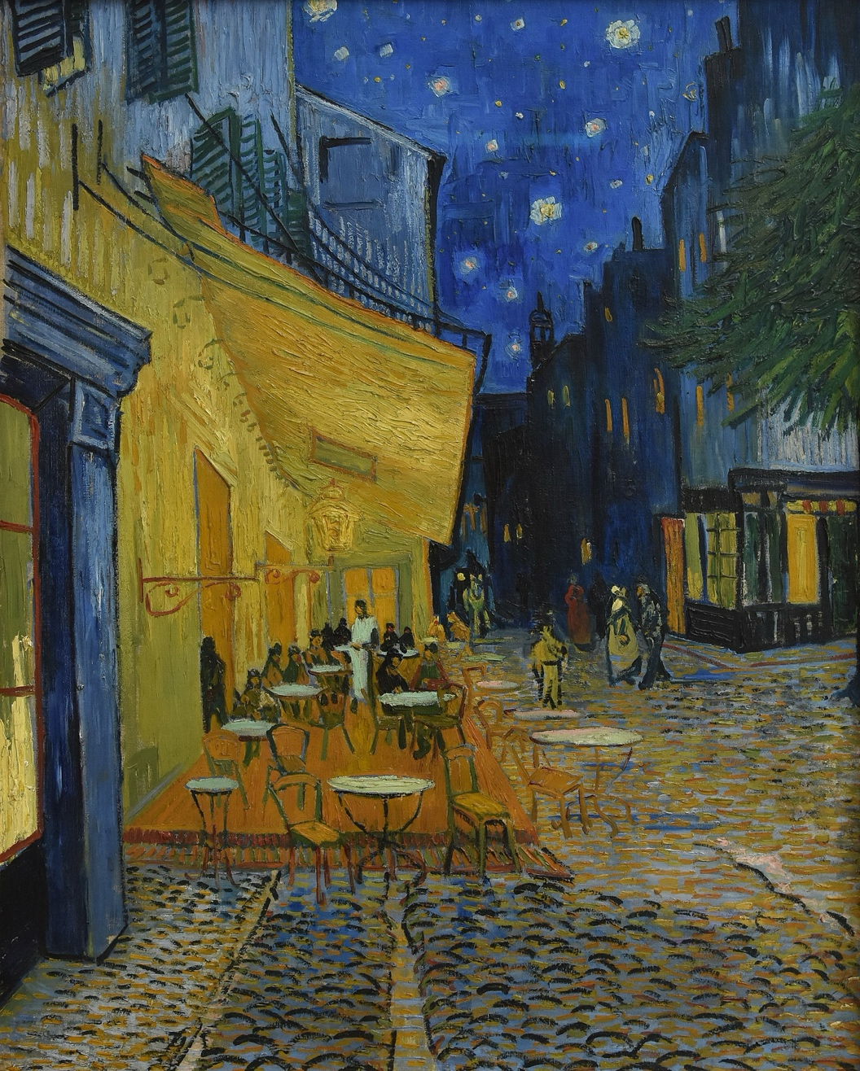

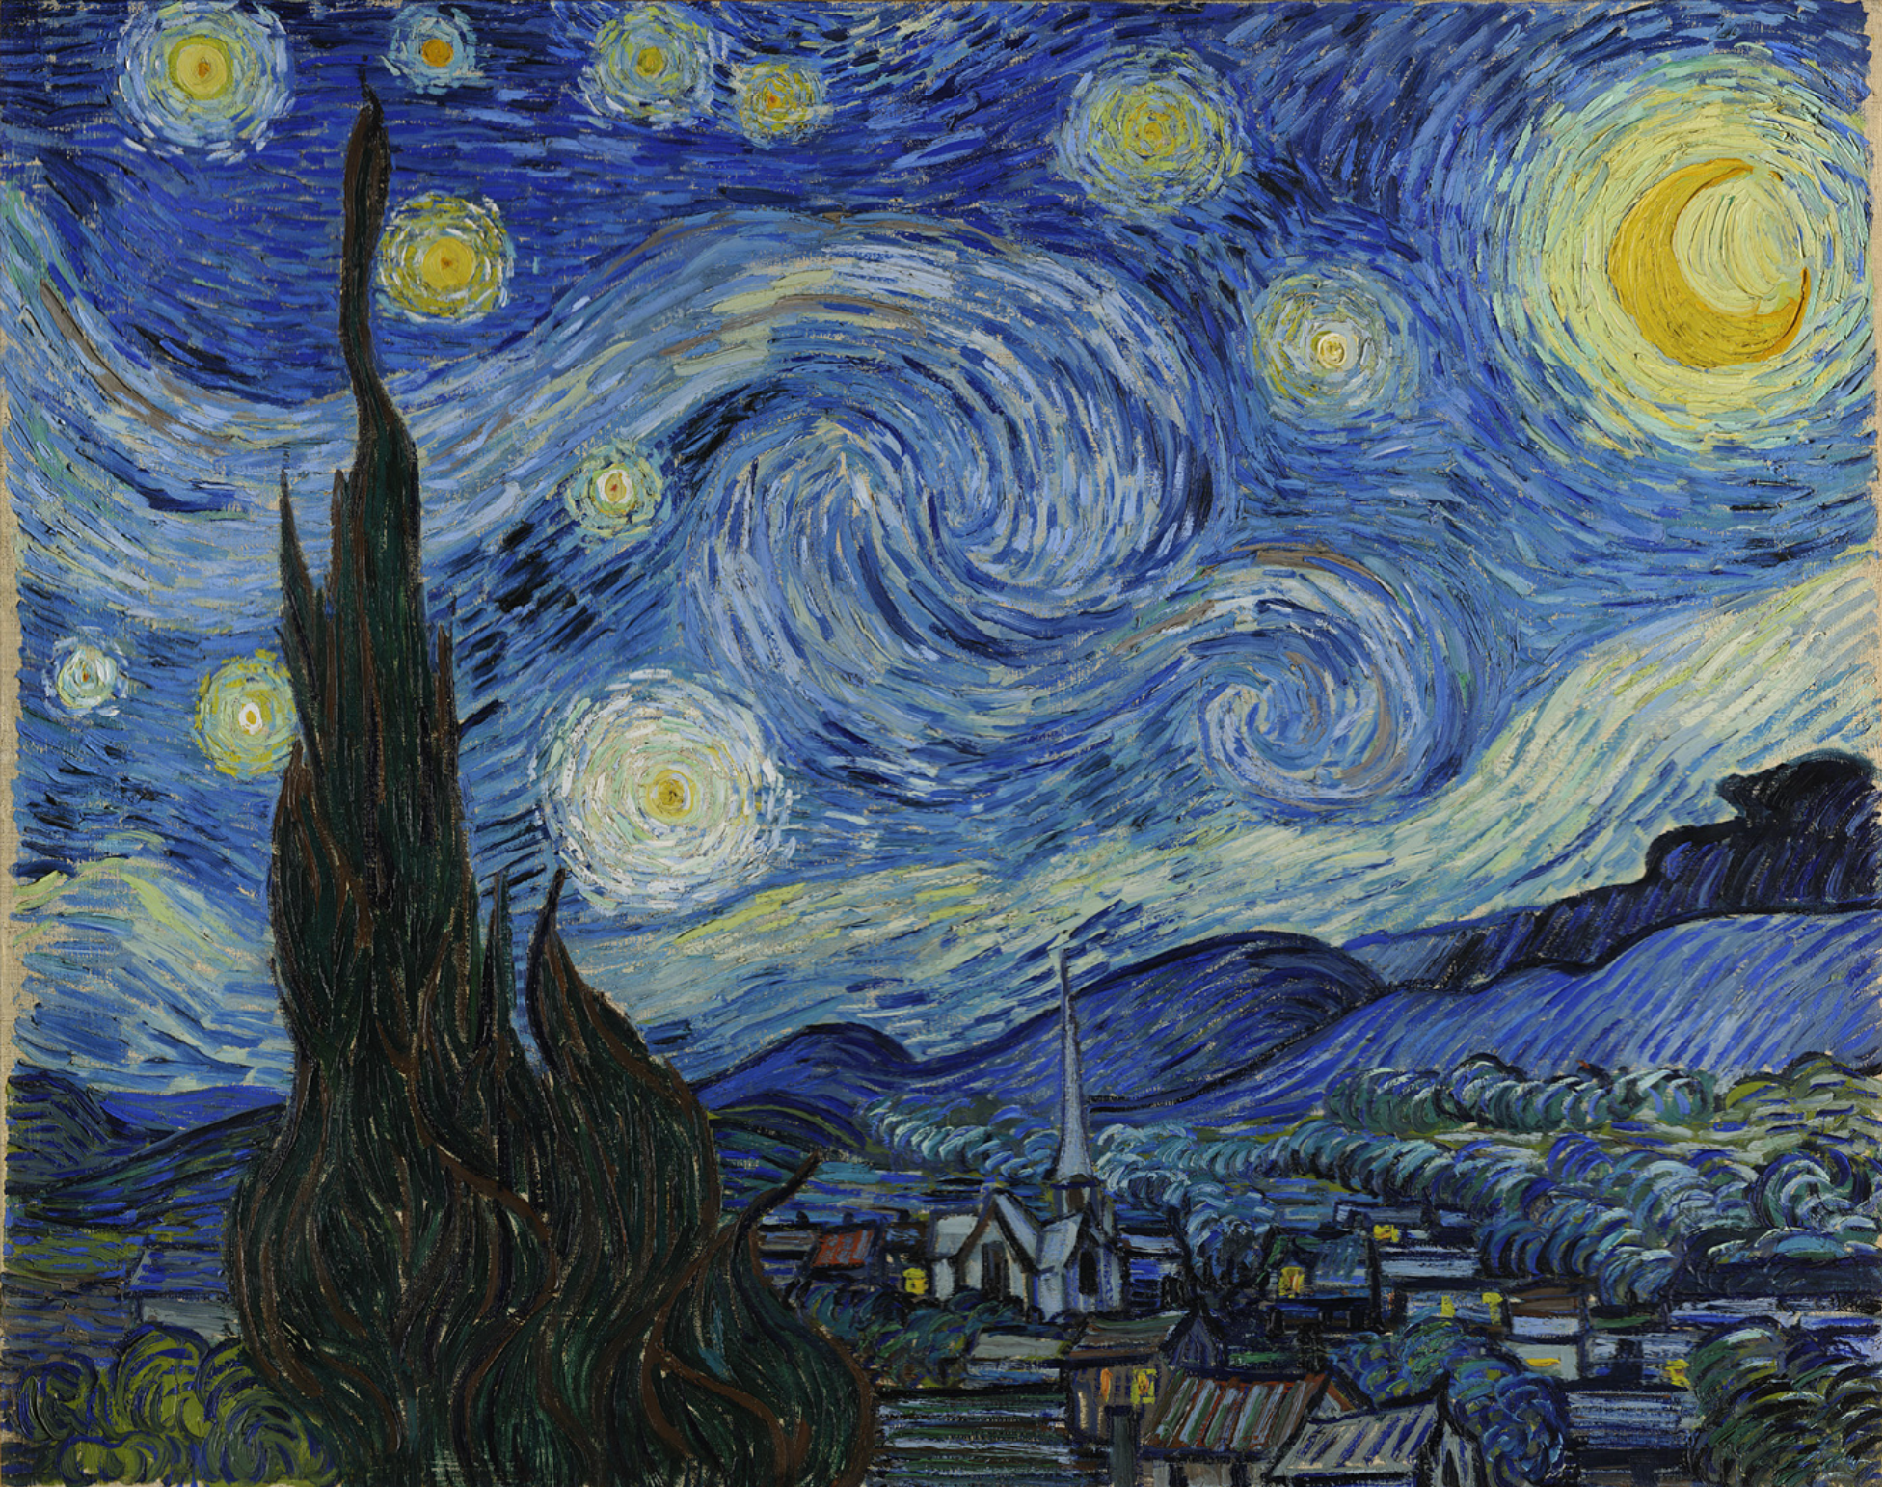 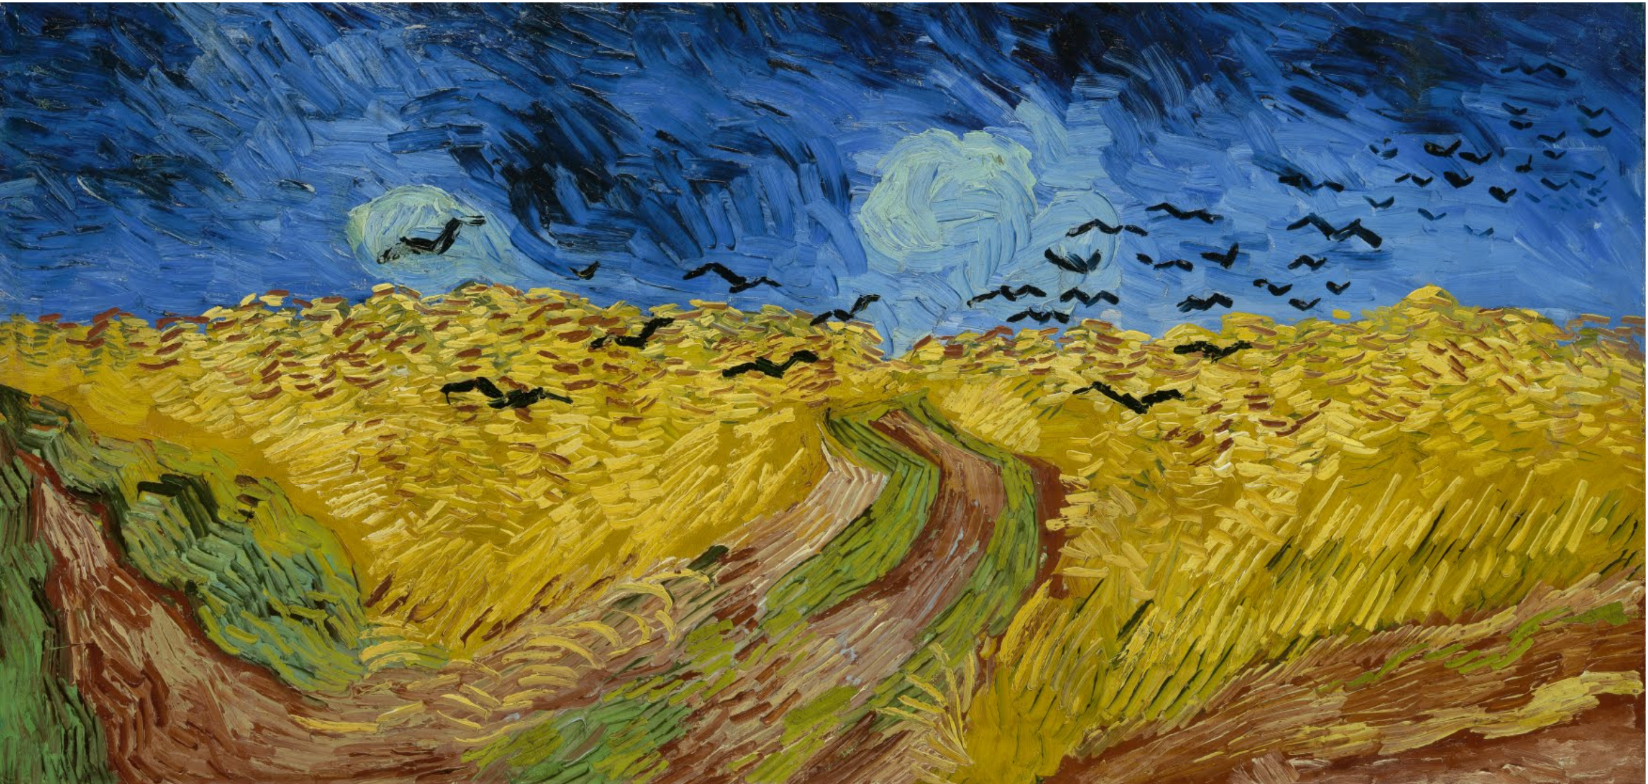

Style: <https://api.mapbox.com/styles/v1/essstherc/cmh4029np003f01qpexxf6tha.html?title=copy&access_token=pk.eyJ1IjoiZXNzc3RoZXJjIiwiYSI6ImNsN2pka2tsMzA4c3c0Mm9iZGxrbmI1d2gifQ.STj4zgpL2uKJ1GH325OGCQ&zoomwheel=true&fresh=true#0/0/0>